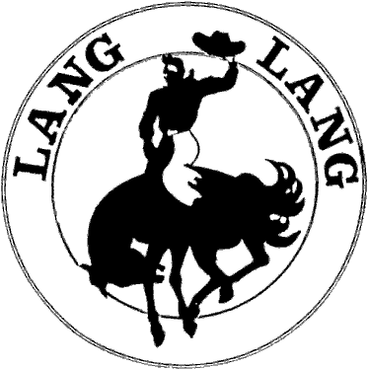
Lang Lang & District Horse Riders Club Inc
(A0060380P)
GRIEVANCE PROCEDURE

There will be a time when a situation will arise that causes a club member some concern. It may be something they have heard around the club, by someone associated with the club or at competitions. Very often these rumours are just that, rumours, which can quickly be put to rest. The committee is very concerned that if left unresolved our members may be ill informed which may lead to unnecessary anxiety. This is not good for the club or its members.
The committee is dedicated to providing a process that enables all concerns to be brought to an appropriate level of authority in the club and resolved.
A grievance may take many different forms, it may also be of a minor nature or more serious. That any member of the Lang Lang & District Horse Riders Club Inc. should feel concerned, aggrieved or generally unhappy with anything going on in the club is unacceptable. Our members require a mechanism in which they can express those concerns in the knowledge that they will dealt with promptly, efficiently and with dignity.
A rider or a riders parent who believes that he/she or his/her child has been discriminated against, sexually harassed, racially vilified or has any other grievance relating to the club, its officials or another rider or parent, and who wishes to lodge a complaint, should note that the Committee will act on a complaint received if the following procedure has been adhered to:
- The matter is to be brought to the attention of the club committee. The committee will consider the nature of the complaint and respond to the complainant with, hopefully, a satisfactory answer as soon as possible.
- Should the complainant feel dissatisfied with the response, the complainant must communicate the problem in writing, to the Committee.
- Should the problem be considered by the President of the Committee to be of a minor nature and easily resolved, a ruling will be made and communicated back to the complainant in writing.
- Should the problem be considered by the President to be of a serious nature, President shall call a “special meeting” of the Executive Committee for consideration of the matter. At that time the President will invite all parties to attend the meeting.
Should the complainant wish to withdraw the complaint prior to the meeting, notification in writing should be addressed to the President

