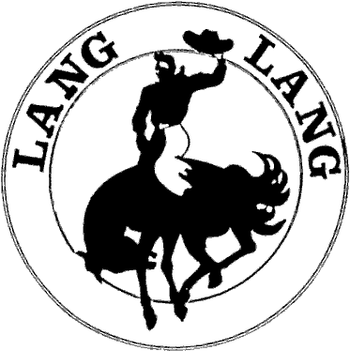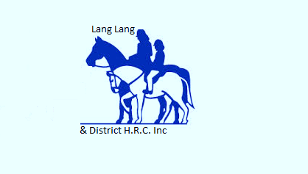Lang Lang & District Horse Riders Club Inc

(A0060380P)

**Member Responsibilities**



**In conjunction with the**

**Horse Riding Clubs Association of Victoria Inc.**

**This document has been adapted from the HRCAV Risk Management Manual and Policy. LL&DHRC members are required to be familiar with their responsibilities as a condition of LL&DHRC and HRCAV membership.**

**Members are expected to abide by the following:**

**Club Policies and Rules**

The Club has in place the following policies and rules relating to health and safety of members, volunteers and the general public. These policies/rules are reviewed and amended as required. Details covering the following issues are provided to all members and relevant persons:

* **Stallions** are permitted at rallies providing the venue permits this and HRCAV stallion rules are applied. Stallion ID kits must be used at all times during Club rallies and the horse must not be moved around venue without a bit. Stallions must be securely double tied or kept in a float, horse truck, stable or steel yard when not being ridden to ensure safety for all horses.
* **Group lesson safety and enjoyment** – LL&DHRC strive to limit group lessons to 6 or less riders with similar riding abilities.
* **Members Code of Conduct:**

Lang Lang & District Horse Riders Club Inc. is a family club for horse lovers and any mistreatment of horses will not be tolerated.

LL&DHRC is a club that embraces the rights, dignity and worth of all regardless of their gender, sexuality, ability, cultural background or religion. It also strives to accommodate all members who may have a disability of any kind.

In accordance with these principles the club strives to maintain a happy atmosphere. To achieve this we need all members to show respect and good manners to our instructors and to other members.

Concerning instructors it may be that an instructor may have different methods than another. Also some exercises may work better with some horses than others. If you are not confident in what is being asked you can speak to the instructor politely and sort something out that will suit you and your horse.

If you still have a problem you can discuss it with the rally coordinator.

IT IS NOT ACCEPTABLE TO RUN DOWN AND CRITICISE INSTRUCTORS TO OTHER MEMBERS, INSTRUCTORS OR ON SOCIAL MEDIA.

Therefore LL&DHRC has a zero tolerance policy of members posting negative comments regarding club members or instructors on any form of SOCIAL MEDIA and/or public forum.

Parents and other onlookers observing a rally group under instruction must not disturb the instruction of the group or interfere with the group.

NO sideline conflicting coaching is to take place while a lesson is in progress.

Members are at all times to conduct themselves in a manner which will not bring the club into disrepute with other clubs, members or the general public when attending rallies and HRCAV events. Members concerned about the code of conduct not being adhered to should advise a committee member.

* Be aware of and show consideration towards members who may not be confident and/or have inexperienced horses.
* Park safely – keep a distance of approximately 9m between your vehicle/float and others.
* Pass vehicles, pedestrians or mounted persons at a safe pace.
* Where possible ride and lunge in enclosed area away from parked vehicles.
* Ensure horses are tied up safely and securely. Never tie a horse up to float that is not attached to car.
* Be appropriately attired, including approved safety helmets and riding boots at all times whilst mounted. Boots to be smooth soled and heeled.
* Members to respect and keep a safe distance from other horses.
* The Risk Management Officer, committee member or instructor to be notified of any potential hazards
* If horse is unsettled or erratic to the extent that it is affecting the safety of other riders in a group, member is expected to remove horse from the situation.
* Abide by rules and regulations of the Club. Abide by all reasonable requests of officials and instructors
* Abide by the HRCAV code of conduct
* There is to be no riding on the Lang Lang Showgrounds oval at any time
* Respect the grounds and ensure that all rubbish and manure is removed at the end of each rally/event and place in the appropriate designated area
* **Permitted saddlery and equipment** - as per HRCAV rules. Gear must be in safe condition, fit the horse and be suitable for the planned activity.
* **Instructors** – are not permitted to ride any other club members horse/s whilst conducting lessons at rallies/club events.
* **Cancellation of rallies** due to weather or other hazards – Refer to LL&DHRC facebook page or web-site the night before the rally.
* **Family members –** are permitted to ride bikes/play whilst lessons are being conducted in a designated area.
* **Dogs** at club rallies & activities – No dogs permitted at rallies and other activities.
* **Volunteering –** as part of being a LL&DHRC Inc Member it is expected that members volunteer throughout the year to support the club (fundraising, working bees, committee members)
* **Alcohol consumption** – responsible alcohol consumption is the responsibility of every member.
* **Swearing** – no excessive swearing.
* **Emergency disease response** – As per Victorian law.
* **Abide by non permitted activities** as identified and informed by committee, risk management officer or instructor

**Club Rallies and Activities**

Members will sign an attendance record before riding. Members are not permitted to ride without signing the attendance record. This is the member’s responsibility.

The Club provides containers holding the following items at each rally:

(a) First Aid Kit for members with a list of contents and re order forms to replace items used

(b) First Aid Kit for horses with a list of contents and re order forms to replace items used

(c) Current Application for Membership completed by each member

(d) Incident Reports

(e) New Membership Applications

(f) Disclaimer Statement

(g) Day Membership Insurance Summary

(h) Day Membership Disclaimer Statement

(i) HRCAV Rules Manual

(j) Copy of Lang Lang & District Horse Riders Club Inc. Risk Management Policy

(k) HRCAV Summary of Insurance Policy

(l) Emergency Plan and Contacts

(m) Fire Blanket

(n) Phone no’s of local Doctor, Ambulance, Police and Fire readily available

**Day Membership** is available for prospective new members to attend 1 rally per annum as a day member. Disclaimer and Day membership Insurance Summary must be completed and rider to pay relevant insurance and instruction fees.

Non-members of LL&DHRC but who are affiliated with the HRCAV may attend 1 rally per annum, but must present their current HRCAV membership card as proof of membership and pay relevant instruction fees.